Preliminary Design Review

Company C

TERMA Case

Document ID: 5

March 11. 2020

Table of contents

**1. Referenced Documents** **5**

**2. Dictionary** **5**

**3. Mission Profile** **5**

**4. Quality Control and Safety** **6**

**5. Design Innovation** **7**

**6. System Design** **8**

6.1 Product Breakdown Structure 8

6.2 Software Design 8

6.3 Electronic System Design 10

6.3.1 System Block Diagram 10

6.3.2 Interface Definitions 11

6.4 Mechanical Design 12

**7. Design and Unique Task Descriptions** **14**

|  |  |
| --- | --- |
|  |  |

Authors:

Hanshuo Yang, 201902791

Jens Jakob Mikkelsen, 201506215

Arsanios Mickael, 201902763

Laurynas Ubys, 201600725

Tomas Samuel Lang, 201902779

Martin Tomko, 201902786

Valeriu-Nicolas Vancea, 201902784

Mircea Melinte, 201911260

Jens Christian Jørgensen, 201406149

János András Németh, 201902765

|  |  |  |  |
| --- | --- | --- | --- |
| Version number | Contributors | Date | Comment |
| 1.0 | HY, JM, AM, LU, TSL, MT, VNV,MM,JCJ,JAN | 11-03-2020 | Initial document. The sections to be completed are added |
| 1.1 | HY, JM, AM, LU, TSL, MT, VNV,MM,JCJ,JAN | 18-03-2020 | All the section were completed |

# 

# 1. Referenced Documents

Table 1. Table of referenced documents

|  |  |  |
| --- | --- | --- |
| Ref. | Doc. No. | Title |
| [SOW] | 1034832-SO | Statement of Work for the Updated Reconnaissance Pod |
| [TRD] | 1034832-DC | Technical Requirements Document for the Updated Reconnaissance Pod |
| [URPP] | 1034832-QC | Updated Reconnaissance Pod Presentation |
| [COPS] | 2 | Concept of Operations |

# 2. Dictionary

Table 2. Glossary table

|  |  |
| --- | --- |
| Term | Description |
| URP | Updated Reconnaissance Pod |
| MRP | Modular Reconnaissance Pod |
| RMS | Reconnaissance Management System |
| ECU | Environmental Control Unit |
| TBD | To Be Determined |

# 3. Mission Profile

The mission profile will be developed with an iterative mindset. The purpose of it is to identify the full and complete product (URP) that will be built, and project it into an easily readable format.

As of Version Number 1.0, the Mission Profile is defined as follows:

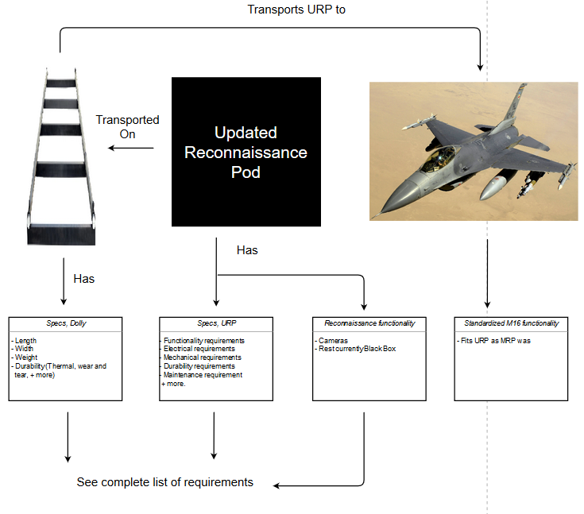

Figure 1. Mission profile

# 4. Quality Control and Safety

In this section there will be presented the constraints imposed by the stakeholders and the safety standards related to the URP.

In order to respect the quality and safety measures, the URP is constrained by the following requirements and standards:

1. It shall be mounted on F-16 AM/BM fighter aircraft in version M6.5.
2. It shall have a mass less than 700 pounds in total.
3. It shall have a geometric cross-section of 0.40 $m^{2}$ or less, as seen from the front.
4. It shall be able to store up to 10,000 images onboard.
5. It shall be able to acquire electro-optical images with a footprint of 600x600 m and a ground resolution distance of less than 10 cm while flying at an altitude of 10 kft at a ground speed of 400 knots.
6. It shall be equipped with at least one of the following sensors: XTS-365-18+IR, CA-265-12+IR.
7. It shall ensure that the temperature around the camera does not change at a rate higher than +/- 3 degrees Celsius per hour in order to avoid condensation when climbing from 0 to 10,000 ft with a climb rate of 50,000 ft/min.
8. It shall be able to acquire electro-optical images of an area with a size 6 km wide and 60 km long in a single flyover at an altitude of 15 kft at a ground speed of 350 knots without image overlap.
9. It shall be able to georeference the imagery with an absolute precision better than 1 m (1 standard deviation).
10. It shall support air-to-air mode, where forward motion-compensation is disabled.
11. It shall be able to adjust the image acquisition to account for the terrain height, given a digital elevation model of the Earth.
12. It shall run on the 115V 400Hz AC power available from the aircraft.
13. It shall have a power consumption less than 6700 Watt.
14. It shall obtain live flight information from the aircraft via its MIL-STD 1553 bus.
15. It shall react properly to the "power-on" signal available as a 28 V discrete signal from the aircraft.
16. It shall react properly to the "zeroize" signal available as a 28 V discrete signal from the aircraft.
17. It shall output live sensor data as RS-170 standard video.
18. It shall be able to destroy all stored data in accordance with AEDP-03, Sanitization Level #2 "Purge" upon receiving a zeroize command.
19. It shall be safe to operate and maintain, meaning that all safety risks shall have a Risk Assessment Code less than "Medium" according to MIL-STD 882.
20. It shall be able to sustain the shock and vibration loads present during flight, mounting and transportation
21. It shall be able to operate under the climatic conditions ranging from "A2 - Hot Dry" to "C2 - Cold" for deployment on aircraft defined in AECTP-230.

# 5. Design Innovation

Compared with the MRP, URP will have several changes, and all of them are non-functional changes except for “including a transportation dolly”.

With the help of the transportation dolly, the URP can be easily mounted and dismounted, and the dolly can even be operated under hot and dry conditions. Therefore, this innovative design can make the maintenance easier.

Among the changes of the pod, two of them are “lighter” and “smaller” respectively. As the weight and size of the pod decreases, it becomes possible and plausible to make the pod include a transportation dolly and fit them inside the jet.

In total, the design not only makes the pod lighter and smaller but also easier to maintain the pod.

# 6. System Design

In this section there will be presented diagrams and tables that will help the reader to better understand the system

## 6.1 Product Breakdown Structure

In figure 2 there are presented the main components of the URP.

[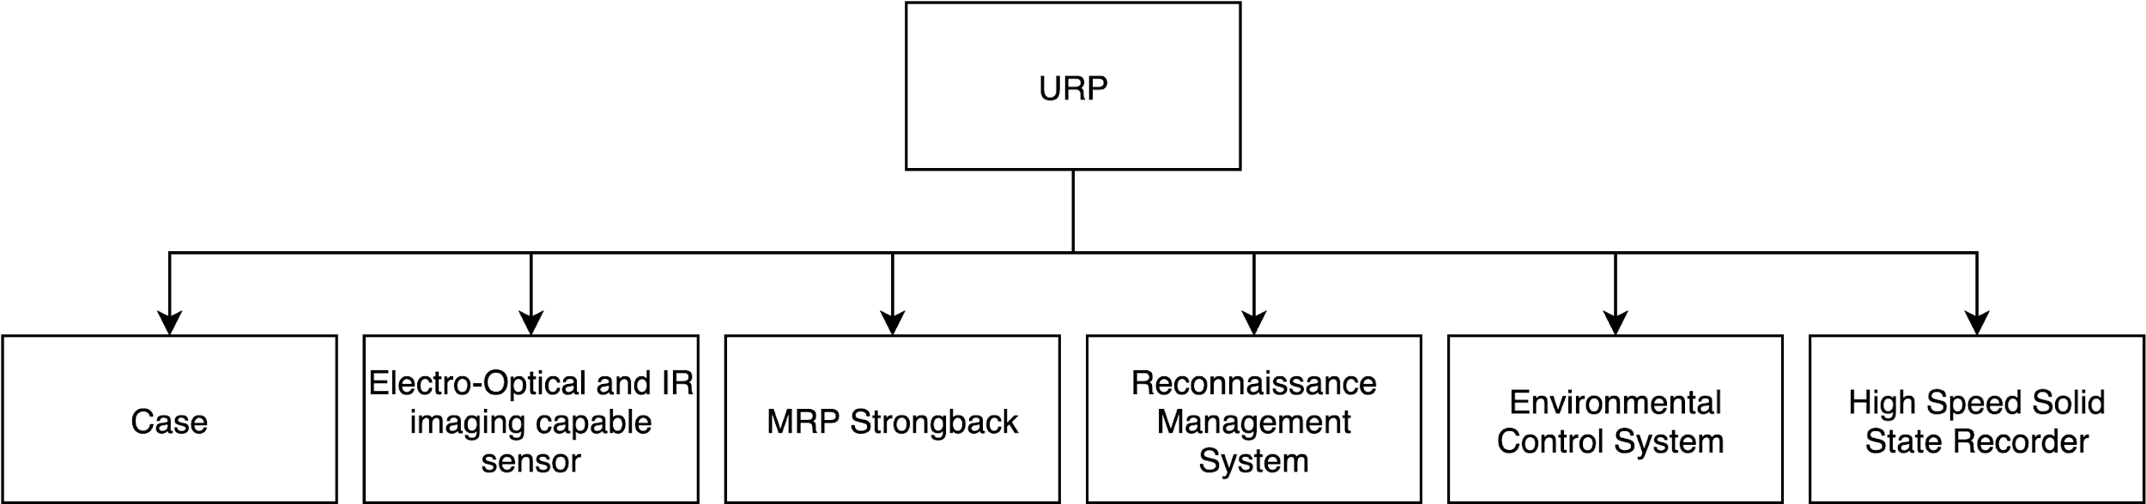](https://www.draw.io/?page-id=9Hm6P9dlSyoHrlMerS2F&scale=auto#G1k-P0eSR5dA16OmHPZfTAzvgfitMVPKXC)

Figure 2. Product breakdown structure

## 6.2 Software Design

Existing RMS software of the MRP will be used as much as possible for the design and development of the new RMS software for the URP. This allows reducing development costs and time. Moreover, reusing software design, which has been tested and proved in the field, increases confidence in the new solution. Therefore, more specific design for the software of the URP will be available after analysing and adopting existing solutions. However, required high level software components and the control flow have been identified and are provided in figure 3. Short descriptions of the identified software components can be found in table 3.

[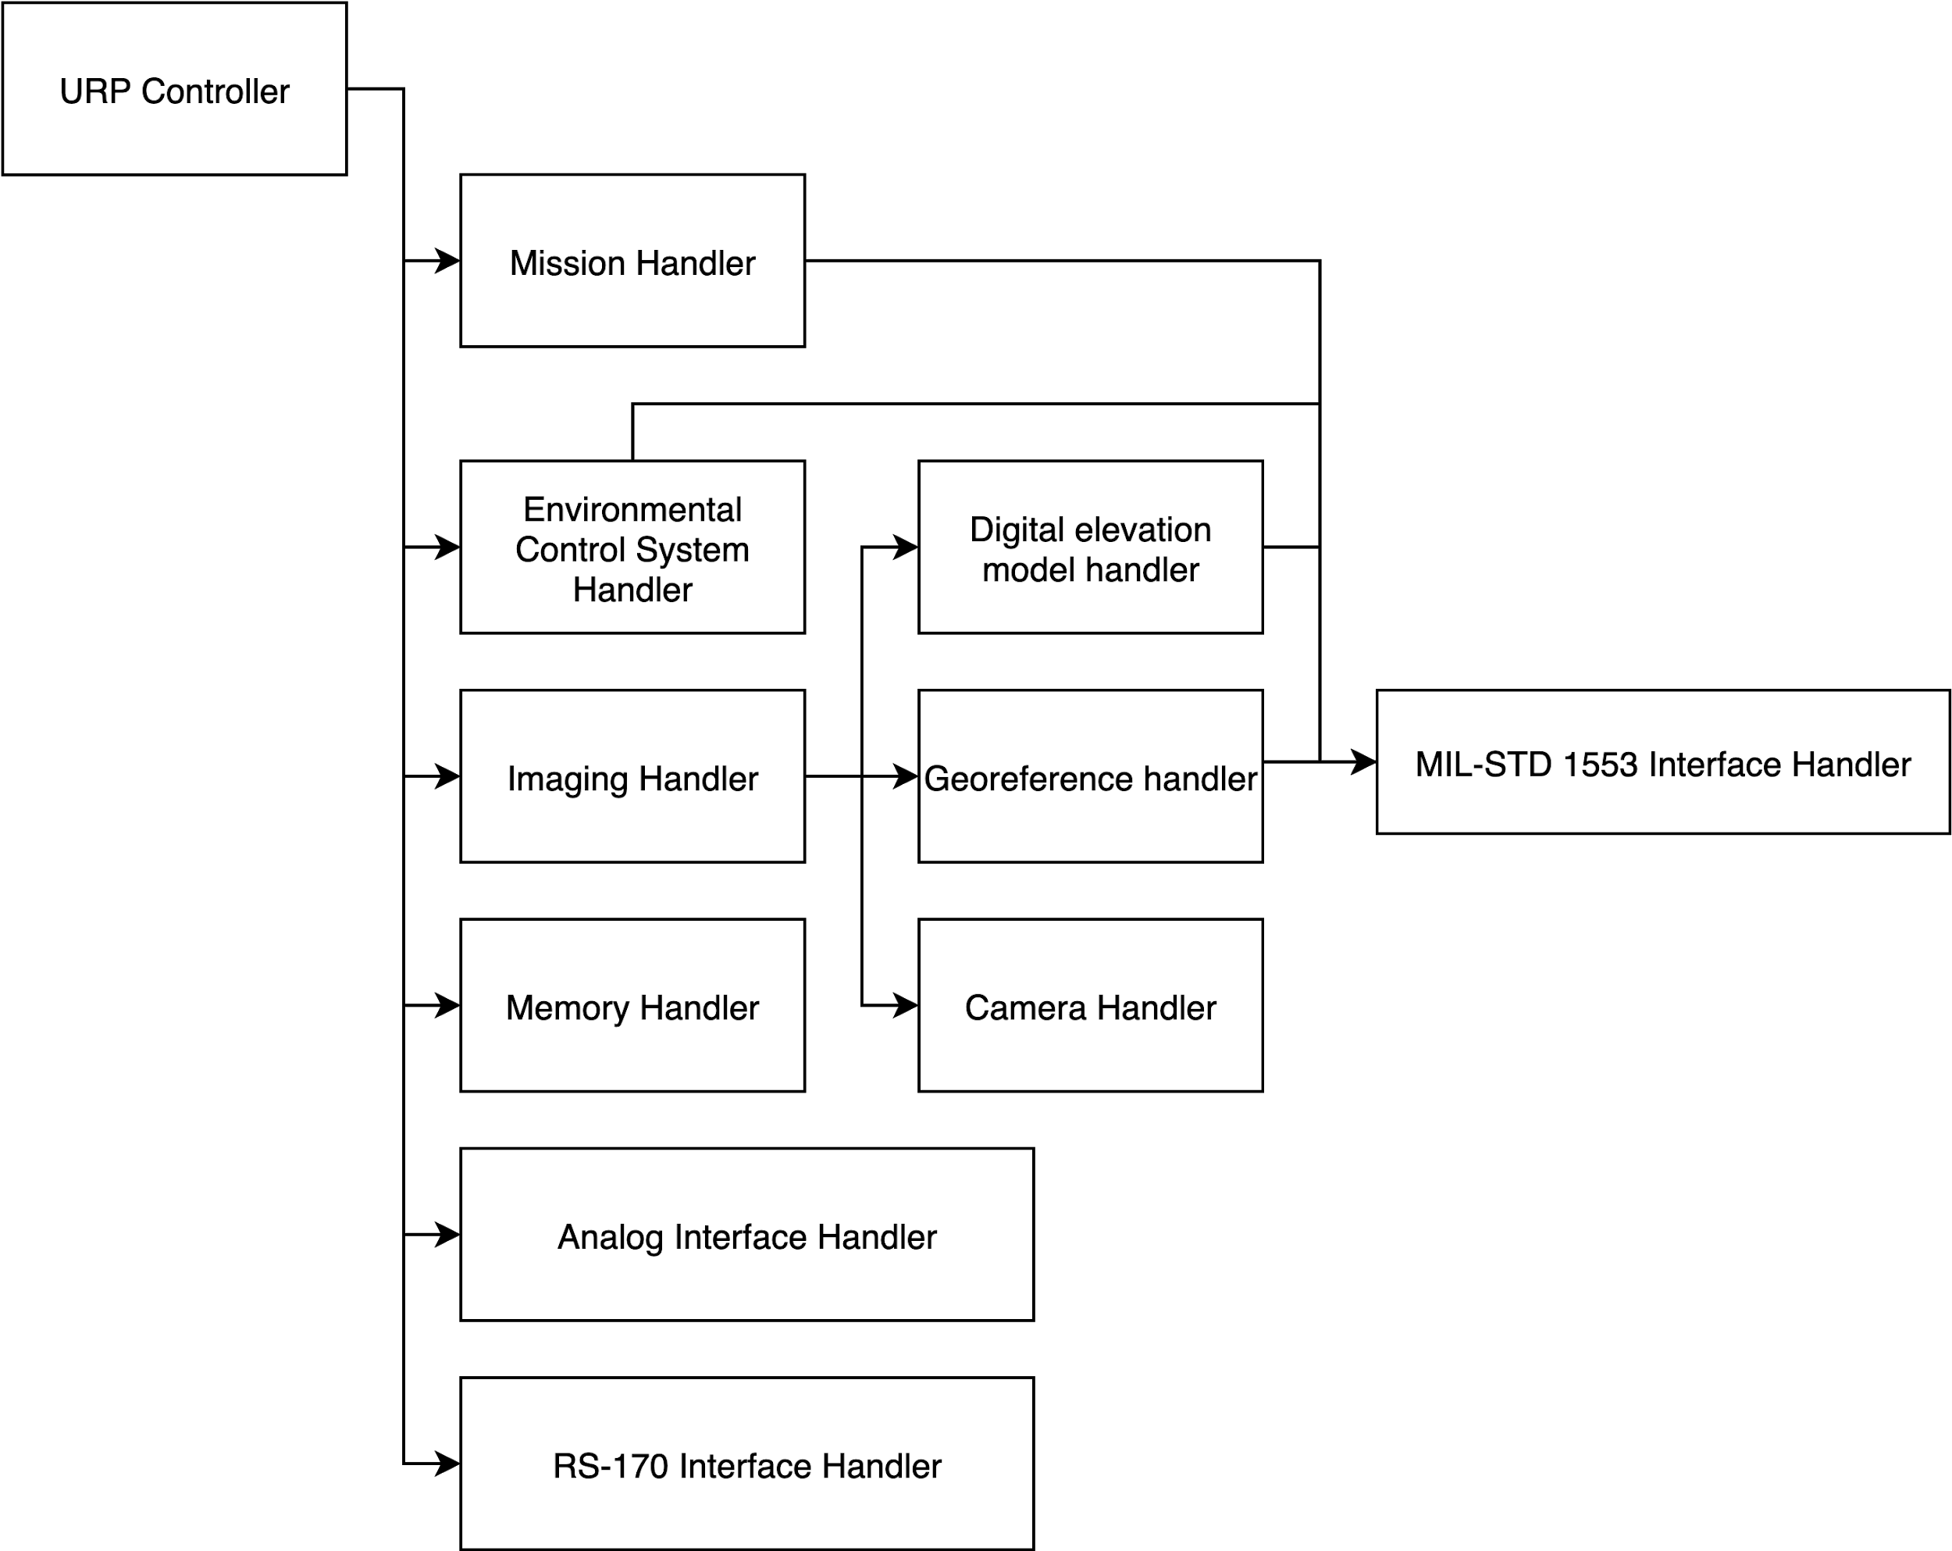](https://www.draw.io/?page-id=GZQbefFPwYDJNbjn9RQz&scale=auto#G11cYatpWkKKoN0xAiHjRjnLnyo0o4r9QK)

Figure 3. High level software design

Table 3. High level software component descriptions

|  |  |
| --- | --- |
| Software component | Function |
| RS-170 Interface Handler | Implements RS-170 standard video interface and provides live video to the cockpit. |
| Analog Interface Handler | Monitors and notifies about **Power On** and **Zeroise** signals from the aircraft. |
| Memory Handler | Handles storing and retrieving images to and from the solid state memory. |
| Imaging handler | Handles overall functionality of capturing images including elevation compensation and georeferencing information. |
| Environmental Control System Handler | Implements interface to the Environmental Control System and ensures required environmental conditions in the MRP. |
| Digital elevation model handler | Obtains and provides relevant elevation information. |
| Georeference handler | Obtains and provides relevant geolocation information. |
| Camera handler | Implements interface to the camera sensor and performs imaging. |
| MIL-STD 1553 Interface Handler | Implements MIL-STD 1553 Interface and provides sensor data from the aircraft. |
| Mission Handler | Handles and provides relevant information about pre planned reconnaissance missions. |
| URP Controller | Top level software component facilitating interactions between other software components and implementing top level functionality of the MRP. |

## 6.3 Electronic System Design

In this section there will be presented the diagrams that will detail the electronics parts of the system and the relationship/interfaces between them and to the environment.

### 6.3.1 System Block Diagram

This section describes main system components and interaction between them. URP Power system describes power to all other system components. Control system controls functionality of other components according to the mission plan. All components have access to the memory system to make them possible to store logs and relevant information.

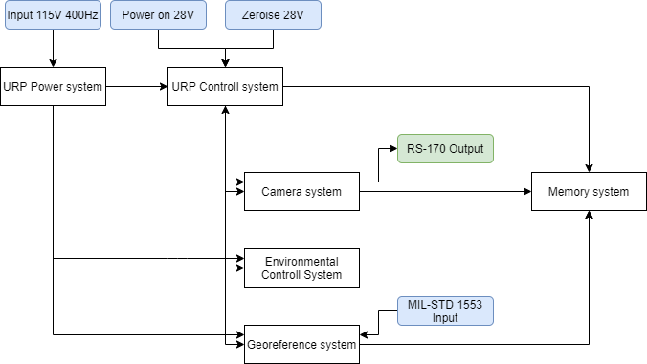  
Figure 4. System block diagram

### 6.3.2 Interface Definitions

This section describes main interfaces that have to be implemented in URP from a software design perspective. URP has to be connected to F-16 and be able to connect to it’s interfaces. URP is working mostly as a standalone module which processes all captured data internally, however it still has to obtain power from F-16 to which is attached and that is 115V 400HZ AC. Analog interface handler has to listen for Power on signal and Zeroise signal (28V). MIL-STD 1553 is used as input data transfer protocol for receiving F-16’s sensor information and RS-170 standard video interface is used as output to send video directly to the pilot’s cockpit. In *Figure 4* is the Interface diagram. To see which module requires a specific interface check *Table 3* diagram from Software design section.

[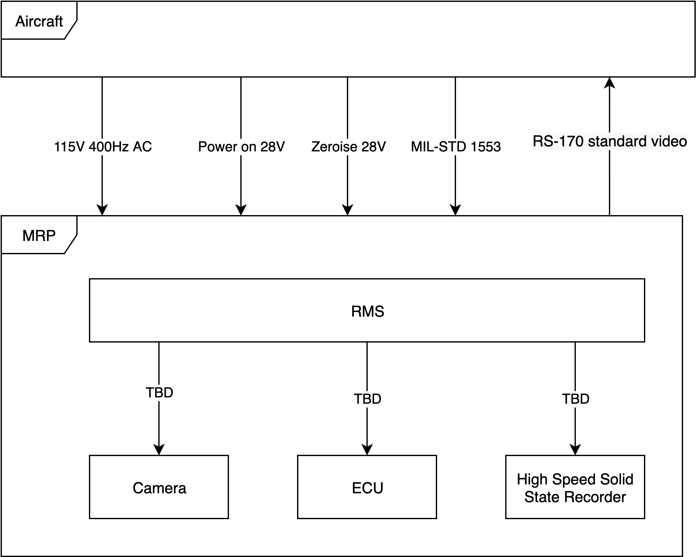](https://www.draw.io/?page-id=Z1MkX8ETlYrFPqgaLrGd&scale=auto#G1O2hCKKJK_7Nqn2TdDrOPuNaZA6XHoqFA)

Figure 5. URP Interfaces

## 6.4 Mechanical Design

This section describes several key components of the URP system design from a mechanical engineering perspective. According to the MRP major components overview analysis from the referenced ConOps document, two important mechanical designs shall be used, namely the choice of the camera module, as well as the ECU, including the selection of the insulation materials choice.

The two mechanical designs mentioned above are represented below, predicated by 3D rendering images of the assemblies in question and followed by detailed description of the said interfaces.

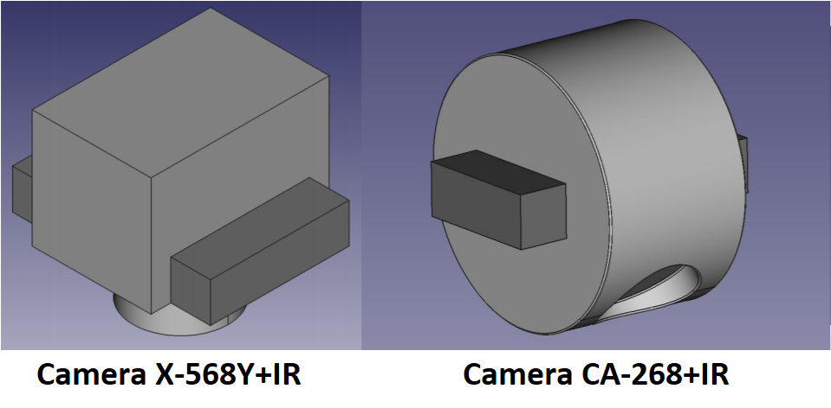

Figure 6. Mechanical design rendering for camera selection

The above figure uses the schematics for the cameras without the IR functionality. It is assumed that the new requested cameras have the same schematics, as new schematics were not provided.

Table 4. Details for the camera selection

|  |  |  |  |  |
| --- | --- | --- | --- | --- |
|  | X-568Y | | CA-268 | |
|  | EO | IR | EO | IR |
| Focal length (mm) | 370 | 200 | 250 | 200 |
| Field of view (degrees) | 11.6913 | 10.5121 | 12.2148 | 10.5121 |
| Frame rate | Swath time (s) | Swath time (s) | Cycle Rate (swath/s) | Cycle Rate (swath/s) |
| (swath 1 image wide) | 0.6 | 1.1 | 5.00 | 2.72 |
| (swath 2 images wide) | 2.7 | 4.6 | 1.818 | 1.069 |
| (swath 3 images wide) | 3.8 | 6.2 | 1.250 | 0.781 |
| (swath 5 images wide) | 6.0 | 9.0 | 0.769 | 0.549 |
| (swath 10 images wide) | 11.5 | 16.1 | 0.392 | 0.261 |
| Resolution (lines/mm) | 217.39 | 121.28 | 186.915 | 121.28 |
| CCD pixels (px) | 16470 x 16470 | 9216 x 9216 | 10000 x 10000 | 9216 x 9216 |
| Weight (kg) | 33.8 | | 37.5 | |
| Pixel depth (bits) | 10 | 14 | 14 | 14 |
| Physical size (mm) | 750 x 450 x 450 | | 780 x 450 x 450 | |
| Power consumption (W) | 520 | | 580 | |
| Price indication (USD) | 9300 | | 11200 | |

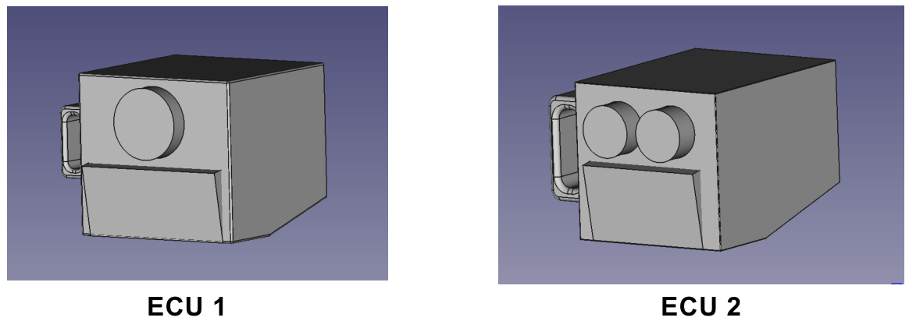

Figure 7. Mechanical design for ECU selection

Table 5. Details for the ECU selection

|  |  |  |
| --- | --- | --- |
|  | ECU 1 | ECU 2 |
| Weight (kg) | 34 | 15 |
| Physical size (mm) | 525 x 600 x 450 | 450 x 420 x 300 |
| Cooling capacity (kW) | 5 | 2.5 |
| Heating capacity (kW) | 3 | 1.7 |
| Cooling type | Ram Air | Compressor |
| Power consumption (kW) | 6.2 | 2.6 |
| Price indication (DKK) | 1,800,000 | 1,500,000 |

Aside from the mechanical designs represented above, the choice of the insulation materials shall be described as part of the mechanical design as well, since it represents an array of physical properties that should be taken into account.

Table 6. Details for the insulation material selection

|  |  |  |  |
| --- | --- | --- | --- |
|  | Foam A | Foam B | Glass |
| Thermal resistance (mK/W) | 32.4 | 20 | 0.98 |
| Mass density (kg/m3) | 1500 | 600 | 2600 |
| Thickness (mm) | > 2 | > 3 | > 2 |
| Price indication (DKK/kg) | 2,000 | 2,800 | 30,000 |

# 7. Design and Unique Task Descriptions

This section describes a high-level set of task definitions, categorized by specific “user stories” and based on their type of systems engineering process. This should provide as a starting point for defining a general purpose backlog, with the intention to be split and prioritized later by the project manager, division responsible and/or engineering team, according to the nature of the task.

There are five defined user stories regarding the URP module and one subsequent user story regarding the transportation dolly. It is assumed that all stories can be developed/implemented in parallel, although some tasks in specific user stories depend on the main controller implementation.

All stories represented in the table below contain an approximate number of hours for the duration of the tasks. It is expected that the assigned responsible or project manager shall approximate each task with more precision and adjust the estimation of the preliminary story duration.

Table 7. Unique task descriptions

|  |  |
| --- | --- |
| User story (approx. hours) | Individual tasks |
| Main controller (60) | - Choose a microcontroller unit to satisfy the AC power and maximum consumption requirements.  - Design schematics for the 4 interface ports via the MIL-STD 1553 bus.  - Create a diagram for intercepting and processing the 28 V “power-on” / “zeroize” discrete signals (via the analog interface).  - Implement the main controller software for the output of live sensor data as RS-170 standard video.  - Implement the stored data destruction interface upon receiving the “zeroize” command in accordance with AEDP-03. |
| Video interface (130) | - Perform the necessary calculations and choose the necessary camera that satisfies the power consumption and physical requirements.  - Design a schematic of including the chosen camera according to the size requirements, as part of the URP.  - Perform trade-off studies for framerate and field-of-view as part of imagery collection.  - Create a PCB electrical schematic for both imaging and collecting images, according to the RS-170 standard. |
| Memory handler (80) | - Perform verification studies for ensuring the data integrity for both reading and writing.  - Perform trade-off, verification and testing studies for the capacity of a storing maximum of 10,000 images.  - Perform trade-off, verification and testing studies for the capacity of a storing maximum of 100,000 images as desirable.  - Implement a read/write handler that communicates with the main controller via the MIL-STD 1533 bus. |
| Imaging handler (90) | - Perform trade-off studies for selecting an electro-optical sensor that satisfies the power consumption requirements.  - Perform the necessary verification of the chosen camera for satisfying the requirements of image footprint, ground resolution distance and velocity/altitude considerations.  - Perform the necessary field-of-view calculations and verifications to confirm the respective requirement satisfaction.  - Implement an imaging handler that controls the respective camera and sends the output to the main controller via the MIL-STD 1533 bus. |
| ECU handler (150) | - Perform the necessary trade-off studies and verifications for ensuring temperature durability of the camera.  - Perform the necessary calculations for the chosen ECU to satisfy the condensation counter-requirements.  - Perform the necessary calculations and design for shock and vibration tests of the pod in general, via Finite-Element modelling.  - Implement the ECU handler that communicates with the main controller via the MIL-STD 1533 bus. |
| Transportation dolly (120) | - Perform the necessary calculations for the choice of materials, for the assembly of the transportation dolly as designed.  - Perform the necessary calculations for satisfying the weight requirements of the transportation dolly.  - Perform verifications for a mechanical handler on the transportation dolly operating at empty and fully loaded states of the F-16.  - Implement a mechanical handler for lifting and lowering the URP, for mount and dismount.  - Perform the necessary verifications and implement specific tests for special climatic conditions (A2 / C2). |